Numerical Analysis Qualifying Exam — January 9, 2016

Instructions
The following are 8 problems in total. Please start each problem on a separate sheet of paper, write on only one side of the paper, and number each page. The time limit on this exam is three hours.

Problems
- Use Taylor’s theorem for a function of two variables to carefully derive and state Newton’s method for the numerical solution of the system of two nonlinear equations:
$$\left\{\begin{matrix}f(x,y)=0, \\ g(x,y)=0.\end{matrix}\right.$$
- Give a sufficient condition which ensures that the Newton method converges.
- Let $x$ and $\tilde{x}$ be the solution of two linear systems: $Ax=b$ and $\tilde{A}\tilde{x}=\tilde{b}$. Show
  - If $A=\tilde{A}$, then
$$\frac{∥x-\tilde{x}∥}{∥x∥}≤cond(A)\frac{∥b-\tilde{b}∥}{∥b∥}$$
  - where $cond(A)=∥A∥∥A^{-1}∥$ stands for the condition number of $A$.
  - Consider the case that $A≠\tilde{A}$. Show that if $∥A^{-1}∥⋅∥A-\tilde{A}∥<1$, then
$$\frac{∥x-\tilde{x}∥}{∥x∥}≤\frac{cond(A)\left[\frac{∥A-\tilde{A}∥}{∥A∥}+\frac{∥b-\tilde{b}∥}{∥b∥}\right]}{1-cond(A)\frac{∥A-\tilde{A}∥}{∥A∥}}.$$
- Recall that for any nonzero vector $v$ of size $n×1$, $I-2\frac{vv^{T}}{∥v∥^{2}}$ is called a Householder matrix, where $I$ is the $n×n$ identity matrix. Show that there exists a sequence of Householder matrices $H_{1},…,H_{n}$ which converts any matrix $A$ into a lower triangular matrix $L$, that is, $H_{n}⋯H_{1}A=L$. (Hint: you may use a $4×4$ matrix to explain how to do.)
- Let $f$ be a continuous function on $[a,b]$. The following statements are true or false. If it is true, give some reasons, e.g., quote a well-known theorem. If it is false, give an example.
  - There exists a sequence of polynomials $p_{n}$ such that $p_{n}$ converges to $f$ uniformly.
  - There exists a sequence of interpolatory polynomials $p_{n}(f)$ which interpolates $f$ at $n+1$ distinct points $x_{i}^{(n)}∈[a,b]$, $i=0,1,⋯,n$ such that $p_{n}(f)$ converges to $f$ uniformly.
  - Let $x_{i}^{n}=a+i(b-a)/n$, $i=0,⋯,n$. The interpolatory polynomial $p_{n}(f)$ at these $x_{i}^{n}$'s converges to $f$ pointwisely.
- Let $p_{n}(x)=\sum_{i=0}^{n}{c_{i}}B_{i}^{n}(x)$ be a polynomial in B-form with respect to $[a,b]$. Here, $B_{i}^{n}(x)=\left({n \atop i}\right){\left(\frac{x-a}{b-a}\right)}^{i}{\left(\frac{b-x}{b-a}\right)}^{n-i}$ is defined on the interval $[a,b]$. Similarly, let $q_{n}(x)=\sum_{i=0}^{n}{d_{i}}{\tilde{B}}_{i}^{n}(x)$ with ${\tilde{B}}_{i}^{n}(x)=\left({n \atop i}\right){\left(\frac{x-b}{c-b}\right)}^{i}{\left(\frac{c-x}{c-b}\right)}^{n-i}$ defined on $[b,c]$. Derive the conditions on their coefficients of $p_{n}$ and $q_{n}$ that ensure
$$\frac{d^{r}}{dx^{r}}p_{n}(b)=\frac{d^{r}}{dx^{r}}q_{n}(b), ∀r=0,1,2$$
- Find an approximation for $Δf(x,y)=\frac{∂^{2}f}{∂x^{2}}+\frac{∂^{2}f}{∂y^{2}}$ using the following four function evaluations: $f(x,y)$, $f(x,y+2h)$, $f(x-\sqrt{3}h,y-h)$ and $f(x+\sqrt{3}h,y-h)$, which form the three corners and the center of an equilateral triangle as shown below. Note that the points A, B, C and D correspond to the locations of these given function values, respectively.
- 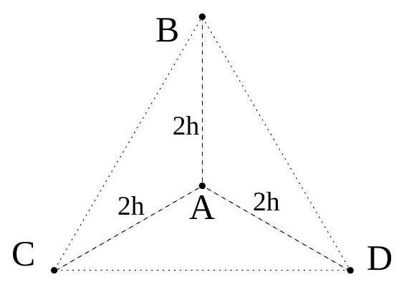
- Figure for Problem 6.
- Show that when the composite trapezoid rule is applied to $\int_{a}^{b}{e^{x}} dx$ using equally spaced points, the relative error is exactly
$$1-\frac{h}{2}-\frac{h}{e^{h}-1}$$
- Derive the general $2^{\text{nd}}$ order Runge-Kutta method for numerical solution of ODE, where $α$ is a variable:
$$\begin{aligned}K_{1}&=hf(t,x(t)) \\ K_{2}&=hf\left(t+αh,x(t)+αK_{1}\right) \\ x(t+h)&=x(t)+AK_{1}+BK_{2}\end{aligned}$$
- In other words, express $A$ and $B$ in terms of $α$.

